Guide to Loot Sources and Loot Pools

Video guide can be found here:
https://youtu.be/gItmHz4ibaE

Of note, most of the terminology is not set in stone, and these are the definitions i use, as such there maybe other places that use a different lexicon to describe this,
also sources aren't really a thing, it's all pools technically, but i find it easier to comprehend when separated out into sources and pools.

Loot Sources:

To condense all the various sources down, we can simplify it down to three sources:
Normal source - normal un-targeted drops
Targeted source - targeted drops
Specific source - chance based drops alongside normal and targeted sources for specific enemies

To give some of the sources as examples (not the complete list):
When killing enemies there is a chance of loot drops, for normal enemies there will always have 1 normal source drop if a drop triggers
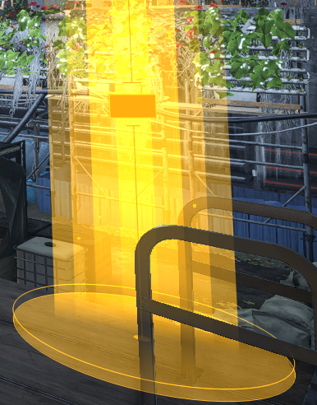 | Normal single  -1 Normal source drop

alongside that there can be 1 targeted source drop, that chance is based of off difficulty and directives
(reddit post by google-1234 about the %-tages of targeted loot and how it works : https://www.reddit.com/r/thedivision/comments/jg8b1y/datamined_targeted_loot_drop_chances_and_an/ )
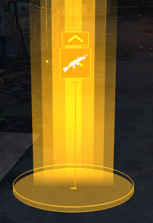 | 1 Normal + 1 Targeted  -1 Normal source drop  -1 Targeted loot drop  (note : chevron inside of loot drop graphic means that the piece has at least one top stat)

Named enemies will always drop at least 1 normal alongside 1 targeted loot, guaranteeing a targeted drop.

Bosses (final named of missions, bounties, summit boss floors etc…) can drop multiple normal alongside 1 targeted source, depending on difficulty.
Bosses are also the only ones to drop a specific source item if there is that opportunity in their pool.
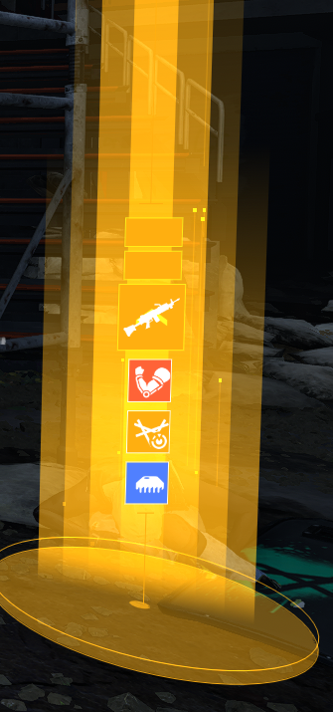 | Heroic boss drop  2 Normal + 1 Targeted  -1st Normal source drop  -2nd Normal source drop  -1 Targeted loot drop  (note : Final named/Boss is also the only one that will drop tactical assessments, it's not all nameds but just the boss)

All items matching current active Targeted Loot will be marked as TL even if it is not from TL source, so you may get a drop with just 2 TL marked items, but even in that case it was still one normal and one targeted, the normal just happened to match the TL of that zone/mission by chance.
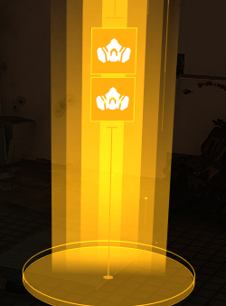 | Still 1 Normal + 1 Targeted  -1 Normal source drop (matching TL so marked as such, but still from normal source)  -1 Targeted loot drop

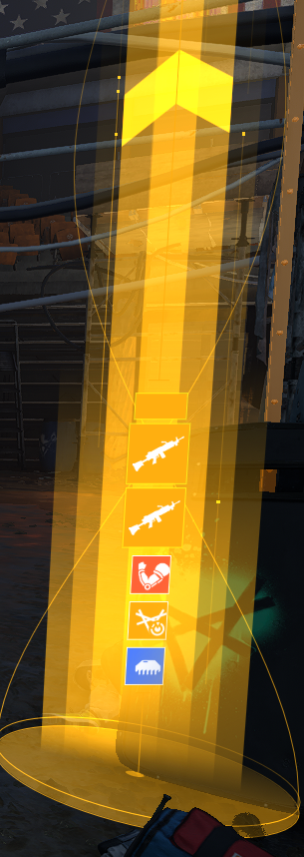 | Heroic boss drop  Still 2 Normal + 1 Targeted  (note : large chevron above the drop stack means there is a named item within the stack)  -1st Normal source drop  -2nd Normal source drop (matching TL so marked as such, but still from normal source)  -1 Targeted loot drop
Specific source (also called unique source) is a extra drop that can happen along side all these type of drops in set situations, it will add 1 extra piece to the stack, the full list for exotics with specific sources is listed under unique source in the “Exotic Drop Locations and Chances” tab of the reddit spreadsheet:
link to Reddit spreadsheet

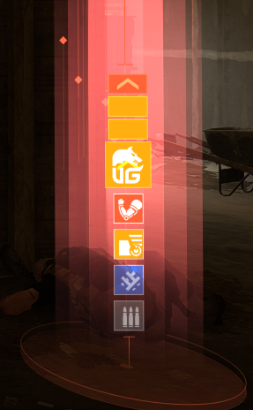 | Heroic boss drop  1 Specific + 2 Normal + 1 Targeted  -1 Specific loot drop  -1st Normal source drop  -2nd Normal source drop  -1 Targeted loot drop

End of mission/activities can reward normals or targetted.

Activities usually give 1 targeted,
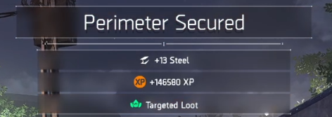
some activities reward 1 targeted +1 normal.
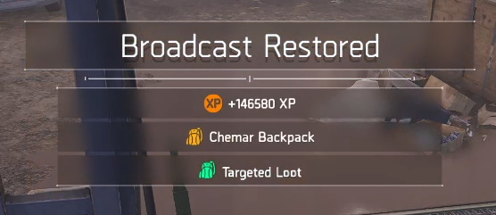

End of mission rewards have a chance of a random item, not guaranteed and from normal source,
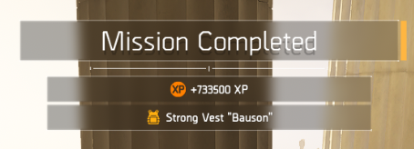
invaded missions on heroic will give a random LZ named as a special source for the first clear of the week, tidal gives 2 random nameds on heroic and 1 on lower diff.
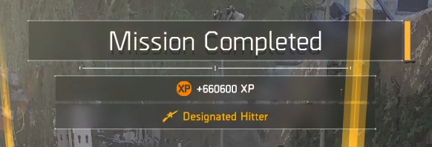
End of mission rewards have a chance of 1 random exotic for heroic(4%) and legendary(5%) difficulty, from normal source
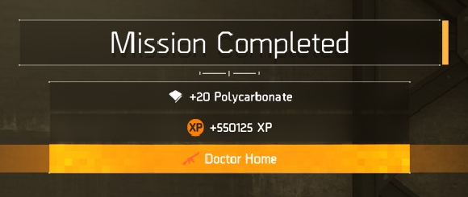

Summit end of 3 floors rewards 1 targeted,
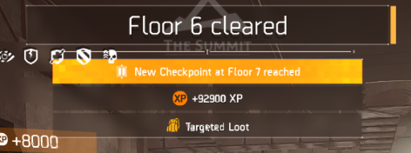
Summit end of boss floors rewards 1 targeted, boss floors have a chance of 1 random exotic alongside it,
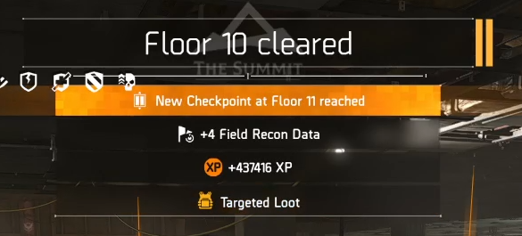
Summit challenges reward targeted loot items at certain stages
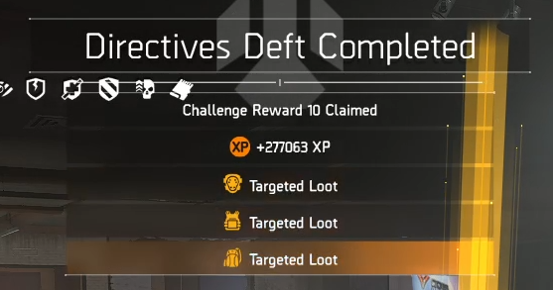

And some of the enemies that guarantee named drops as a specific source:
Countdown final 4 hunters - untargeted nameds from the LZ named pool
Final PVE rogue - untargeted named from the LZ named pool
The four minor manhunt targets - untargeted named from the LZ and DZ named pools

Loot Pools:

All sources are linked to pools,
pools are selections of available gear/weapons currently droppable from a source,
some pools are affected by difficulty and if you have met certain criteria for some of their drops, for instance having the blueprints for some of the exotics for them to be in certain pools,

to describe some of the pools, and here as well, this isn't an exhaustive list, but the basics :

For normal source, it depends on if you are in the LZ or the DZ as it will pull from each based on your location,
The LZ normal pool is all LZ items (meaning excluding dz brands and dz nameds for instance), completely unaffected by targeted selection.
Inversely the DZ pool does contain those dz brands and nameds, but there are some nameds that are LZ only and those are then omitted.
Importantly the normal pool is completely untargeted and vast, meaning it is very unlikely to get something specific from it, drops from normal source by extension aren't good for directed farming

Targeted source pulls from dozens of smaller targeted pools and those have the same DZ and LZ variations, meaning each brand/slot/weapontype selection is its own pool containing only that limited set of items, and only 1 TL will be active at a time.
A Targeted Loot zone/mission will have all the items of that brand/slot/type, and depending on if you are LZ or DZ it will drop available items of that pool depending on where it is coming from, as some are dz/pvp items.
Each targeted pool for brands is all the items of that brand and their nameds,
for slots and weapon types it is all normal items and nameds, but also (available) exotics as well.

Specific source for loot is pulling from specific pools mostly depending on what made the drop, some enemies will have set drop that have a chance to trigger alongside the normal and targeted sources,
Notably for loot, some faction bosses can drop certain exotics, and some specific bosses even have specific exotics tied to them.
Technically things like keydrops and tac assessment drops can be said to be specific pool drops.

There are dozens of other pools still as well,
For instance named caches pull from a pool that is all LZ and DZ named, legacy caches pull from a pool of all previous season reward track items, current season caches pull from a pool of all the items of current season reward track items, and there are many more.

There is a character specific exotic pool, which is a list kept by the game as to which exotics are available to drop for the current active character,
certain exotics are not available to drop till certain prerequisites are met, these include some of the exotics that have a “quest” that will give the first one, and current season exotics are intended to not drop until you get your first one from the season reward track.
The full list can be found in the reddit spreadsheet, all exotics listed with yellow on the “Exotic Drop Locations and Chances” require something to be done before they enter your exotic pool.
Link to Reddit spreadsheet
Also exotic caches pull from this pool, and so do the end of mission rewards exotic if you receive one.

Some conclusions

Normal source is a huge pool, if you can get something from a targeted source, you are hugely increasing your chances.

When choosing between a specific source or a targeted source, in most cases it is better to go targeted, for example JTC final boss has a 7% chance for the coyote mask, but current consensus is that it is better to farm targeted loot in countdown/FL90 for a overall faster farm, as it is one 7% every 10 mins versus a tinier chance but dozens of times more. This will be somewhat dependent on the specific comparison made of course.

When farming specific gear slots of a brand or nameds, choose brands over slots, as it is a smaller pool meaning more chances.
Weapon type and gear slot are useful when farming for exotics.

Quirks

As all pools seem to be entered by hand, and have had and have errors in them, meaning that there are some items that should drop, but won't due to errors in entries of pools.

For instance in the past, the closer and the setup were in the normal pool, but were mistyped in the targeted pools on Uzina, meaning you could get them from normal source, but they would not drop from targeted source, making it quite hard to farm as it meant going after them without the huge chance increase that targeted loot provides,

Currently Catharsis, Bluescreen and Dread Edict have this issue, where they are in the normal pools, but not in their targeted gearslot or weapontype, meaning you can get one with the chances of normal source giving you one either as a drop or from a exotic cache, but you cannot target farm for them at all.
And Busy Little Bee is incorrectly linked to the Liberty blueprint, meaning that that is the prerequisite for it to drop instead of its own blueprint.

Links to my other guides, the Build Collection, DMG/DPS Calculators and many other things:

https://docs.google.com/document/d/15mg-_sjowh5_8bUp2VIBqnDxCDqz-xJOISl0DlG3RDU

